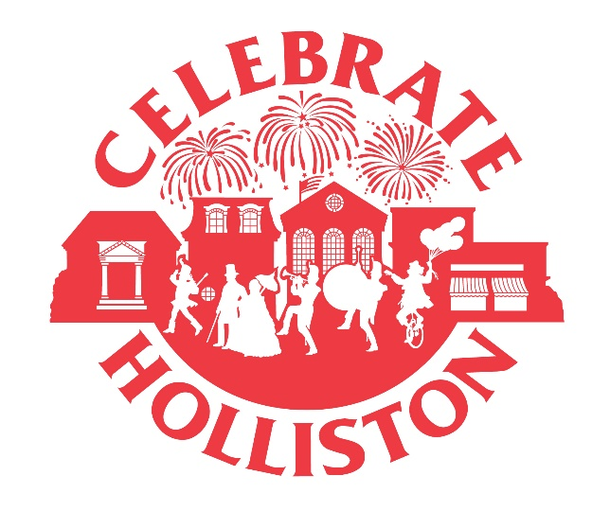

Celebrate Holliston – Citizen of the Year
For Immediate Release
Further information contact:
Lina Arena-DeRosa - linaad19@gmail.com
Jane Gilfoy – Bgilfoy@aol.com

Do you know someone who is an extra ordinary volunteer that is committed to making Holliston a very special place to live? If you do, Celebrate Holliston is currently looking for nominations for Citizen of the Year.

On Saturday September 21, one man and one woman are honored at Celebrate Holliston’s Field Day. You can vote for a nominee at www.celebrateholliston.com/vote.htlm. Forms and ballot boxes are also available at Town Hall, Coffee Haven, Superette, Holliston Library, Bazels and The Depot Package Store beginning on Monday June 24th.

Nominations are open until August 31 and will be chosen by the Celebrate Holliston Committee at its early September meeting.

So vote for the unsung hero of Holliston and join us at Celebrate Holliston’s Field Day on September 21!

